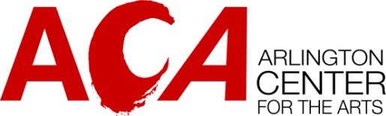

Arlington Center for the Arts
Private Artist Studios Rental Information

Arlington Center for the Arts is pleased to announce that applications are being accepted for private studio rentals. We look forward to welcoming resident artists who create unique, dynamic work and also contribute to the energy and vibrancy of our community.

Annual leases will apply to private studios and rent will be due monthly in advance

To Apply
The application is available at www.acarts.org/studio-artists. Applications will be accepted on a rolling basis based on availability of studio spaces. Selected artists will be invited for interviews and tours of the space.

Decision Criteria:

- Quality of the artwork in both content and technique
- Application of artistic practice within ACA space (safe materials, limited spaces, etc. - - i.e. our space cannot accommodate large scale sculptures)
- Benefit to the ACA Community: preference will be given to artists who are or would like to be active members of ACA
- Ability to work well with others in a community space
- Two references will be requested

Private Studio Rentals include:
- Vibrant and collaborative work atmosphere
- Opportunities to show and sell artwork
- WiFi and utilities included
- Access to common area sinks
- 24/7 studio access
- Access to shared studio after 6pm and on weekends
- Participation in annul Arlington Open Studios is expected for all tenants

Private Studio Rentals DO NOT include:
- ACA membership
- Gallery entry fees
- Furniture, equipment or materials
- Classroom Access
- Any storage of artwork or materials outside the tenants private studio at any point

Tenancy Conditions

Private Artist Studios will be leased for a period of 12 months with an offer to renew up to five consecutive years. After five years, studio applications will be open to the public and a new tenant may be accepted, in order to ensure community access.

Arlington Center for the Arts shall be permitted to terminate the lease agreement at any time we deem that a member is causing disruption to the studio or any others using the studio, or member fails to follow the conditions of their lease.
All artists who are part of the Studio Artist program are required to obtain liability insurance. More information on this will be provided during the interview process.

Studios are available for personal use. Subletting or teaching is NOT permitted.

Please note: ACA is a tenant in a town owned building and occasionally, we experience facility issues that are beyond our control. We will do our best to communicate about issues as they arise.

All artists are eligible regardless of race, ethnicity, gender identity and expression, belief, national origin, sexual orientation or physical abilities. Artists and curators from the greater Boston area are encouraged to apply. All applicants must be age 21 and up.

